EXP 1T07 N. GOVINDA SAI (192312220)
ECE(ITA1425)
1. Execute and display the results of rm, users, and tree
Aim
To execute and study the rm, users, and tree commands in Kali Linux and observe their outputs.
Software Used
- Kali Linux Operating System
- Kali Linux Terminal
Procedure
- Open the Kali Linux Terminal.
- Create a sample file using the touch command.
- Use the rm command to delete the file.
- Execute the users command to display the logged-in users.
- Execute the tree command to display the directory structure.
- Observe and record the outputs.
Commands Executed
touch test.txt
rm test.txt
users
tree

Output:
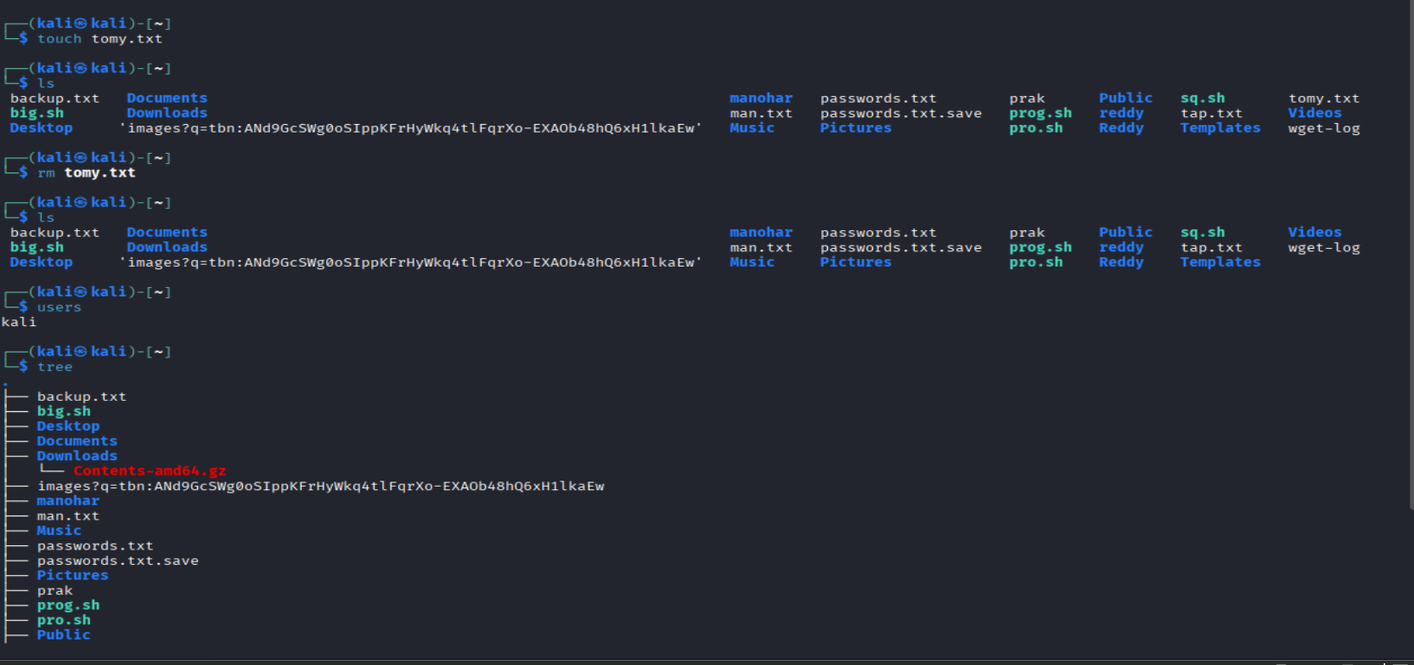
Result
The rm command successfully deleted the file, users displayed the logged-in user, and tree displayed the directory structure.
Conclusion
Thus, the rm, users, and tree commands were successfully executed in Kali Linux.

2. Execute and display the results of less, more, and vi
Aim
To execute and study the less, more, and vi commands in Kali Linux and observe their outputs.
Software Used
- Kali Linux Operating System
- Kali Linux Terminal
Procedure
- Open the Kali Linux Terminal.
- Create a sample text file.
- Use the less command to view the file contents.
- Use the more command to view the file contents.
- Use the vi command to open and edit the file.
- Observe and record the outputs.
Commands Executed
touch sample.txt
less sample.txt
more sample.txt
vi sample.txt
For vi, press i to type, then Esc, type :wq, and press Enter to save and exit.

Output:

Result
The less and more commands successfully displayed the file contents, and the vi command successfully opened the file for editing.
Conclusion
Thus, the less, more, and vi commands were successfully executed in Kali Linux.
Experiment 3: Execute and Display the Results of Tree, Head and Tail Commands in Kali Linux
1. Aim
To execute and display the results of the tree, head, and tail commands in the Kali Linux operating system.
2. Software Required
- Kali Linux Operating System
- Terminal
3. Algorithm
- Start the Kali Linux operating system.
- Open the Terminal.
- Create a sample directory and files using the mkdir and echo commands.
- Execute the tree command to display the directory structure.
- Execute the head command to display the first 10 lines of a file.
- Execute the tail command to display the last 10 lines of a file.
- Observe the output and verify the results.
4. Procedure, Commands and Output
A. Tree Command
Purpose: Displays the directory structure in a tree-like format.
Step 1: Open Terminal and create sample directories.
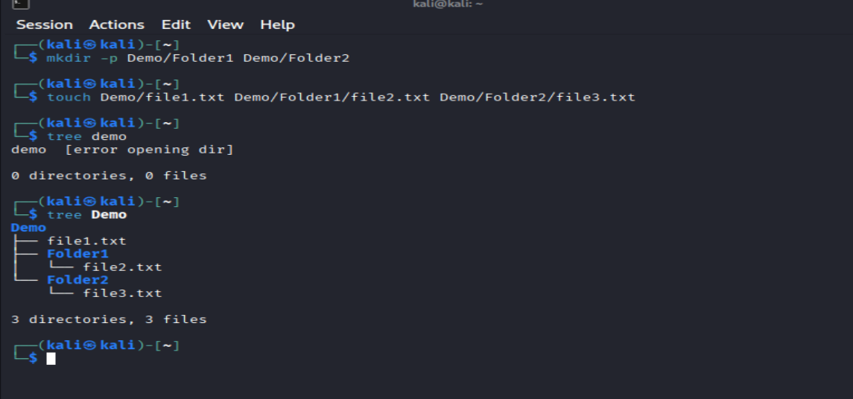
B. Head Command
Purpose: Displays the first 10 lines of a file by default.
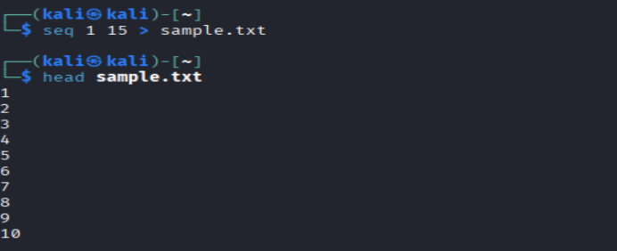
C. Tail Command
Purpose: Displays the last 10 lines of a file by default.
Step 1: Use the same sample.txt file created above.
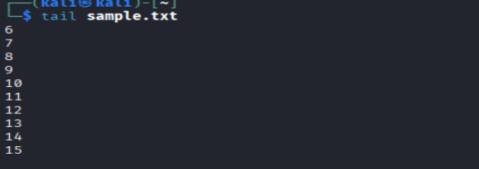
Result
Thus, the tree, head, and tail commands were studied and executed successfully in Kali Linux. The tree command displayed the directory structure, the head command displayed the first lines of a file, and the tail command displayed the last lines of a file.

Experiment 4: Execute and Display the Results of ls, cat, and mkdir Commands in Kali Linux
1. Aim
To execute and display the results of the ls, cat, and mkdir commands in the Kali Linux operating system.
2. Software Required
- Kali Linux Operating System
- Terminal
3. Algorithm
- Start the Kali Linux operating system.
- Open the Terminal.
- Execute the mkdir command to create a new directory.
- Execute the ls command to list files and directories.
- Create a text file and add sample content.
- Execute the cat command to display the file contents.
- Observe the output and verify the results.
4. Procedure and Output

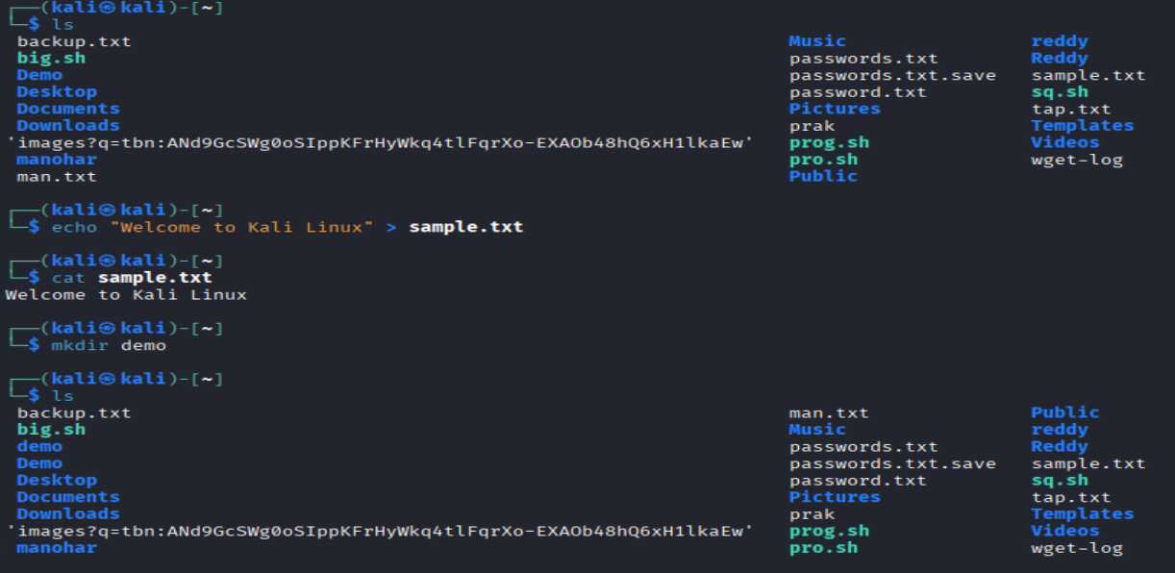

Result
Thus, the ls, cat, and mkdir commands were executed successfully in Kali Linux. The ls command listed files and directories, the cat command displayed file contents, and the mkdir command created a new directory.
Experiment 5: Execute and Display the Results of Uptime, Date, and Mv Commands in Kali Linux
1. Aim
To execute and display the results of the uptime, date, and mv commands in the Kali Linux operating system.
2. Software Required
- Kali Linux Operating System
- Terminal
3. Algorithm
- Start the Kali Linux operating system.
- Open the Terminal.
- Execute the uptime command to display the system running time.
- Execute the date command to display the current date and time.
- Create a sample file using the touch command.
- Execute the mv command to rename the file.
- Verify the output using the ls command.
4. Procedure and Output
i) uptime Command
Purpose: Displays how long the system has been running.
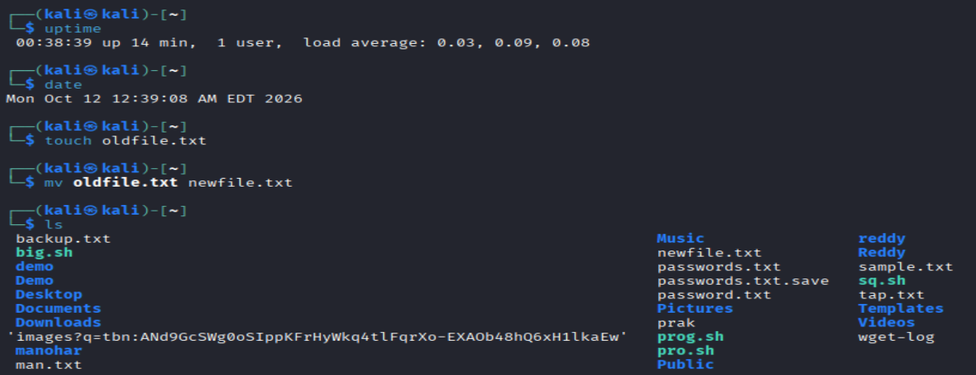
Result
Thus, the uptime, date, and mv commands were executed successfully in Kali Linux. The uptime command displayed the system running time, the date command displayed the current date and time, and the mv command renamed a file successfully.
Experiment 6: Execute and Display the Results of Touch, Pwd, and Wget Commands in Kali Linux
1. Aim
To execute and display the results of the touch, pwd, and wget commands in the Kali Linux operating system.
2. Software Required
- Kali Linux Operating System
- Terminal
- Internet connection (for wget)
3. Algorithm
- Start the Kali Linux operating system.
- Open the Terminal.
- Execute the touch command to create an empty file.
- Execute the pwd command to display the present working directory.
- Execute the wget command to download a file from the internet.
- Verify the downloaded file using the ls command.
- Observe and record the output.
4. Procedure and Output
i) touch Command
Purpose: Creates an empty file or updates the timestamp of an existing file.
Step 1: Open the Terminal.
Step 2: Execute the command.
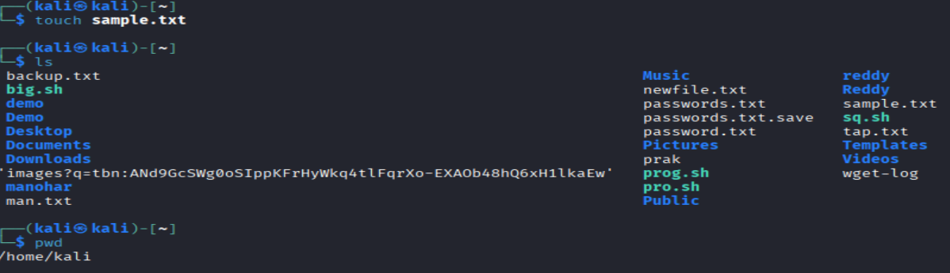
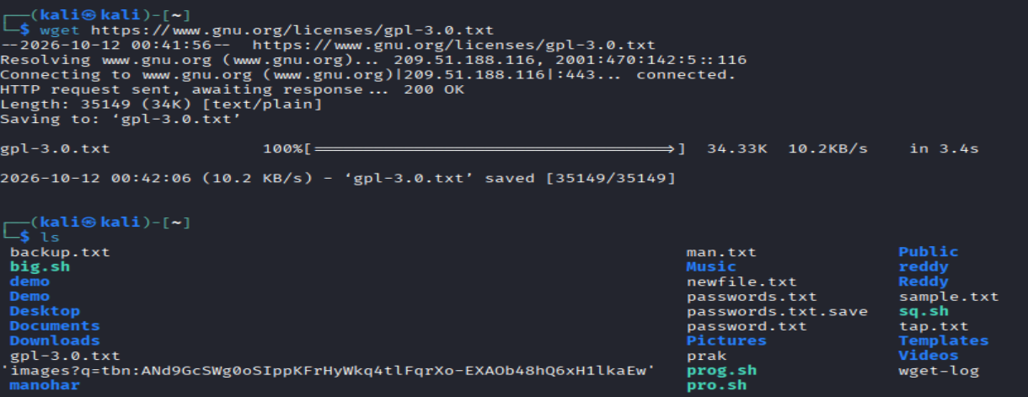Result
Thus, the touch, pwd, and wget commands were executed in Kali Linux. The touch command created an empty file, the pwd command displayed the current working directory, and the wget command downloaded a file from the internet.

Experiment 7: Execute and Display the Results of cd, cp, and ls Commands in Kali Linux
1. Aim
To execute and display the results of the cd, cp, and ls commands in the Kali Linux operating system.
2. Software Required
- Kali Linux Operating System
- Terminal
3. Algorithm
- Start the Kali Linux operating system.
- Open the Terminal.
- Execute the mkdir command to create a sample directory.
- Execute the cd command to change the current directory.
- Execute the cp command to copy a file.
- Execute the ls command to list files and directories.
- Observe and record the output.
4. Procedure and Output
i) cd Command
Purpose: Changes the current working directory.
Step 1: Create a directory.
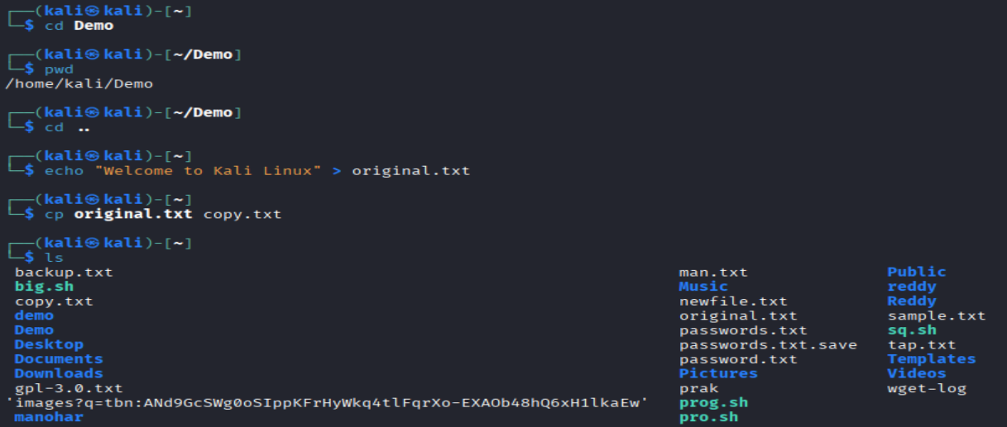
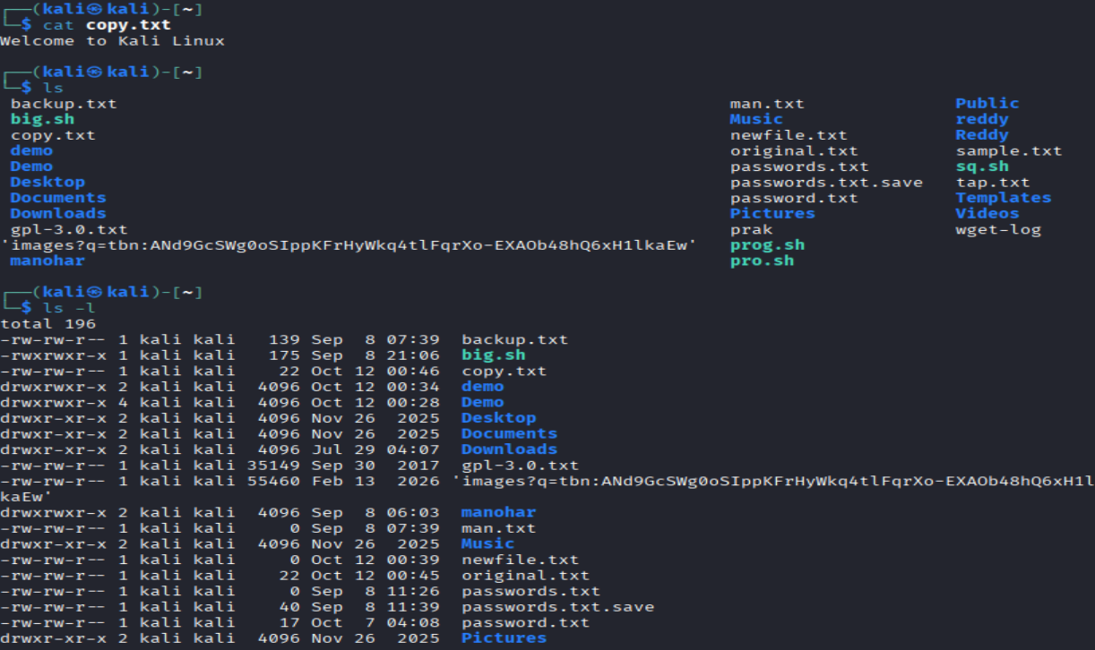
Result
Thus, the cd, cp, and ls commands were executed successfully in Kali Linux. The cd command changed the working directory, the cp command copied a file, and the ls command displayed the files and directories.

Experiment 8: Nmap Service Version and OS Detection Commands in Kali Linux
1. Aim
To execute Nmap commands in Kali Linux to detect service versions, perform an aggressive scan, and identify the operating system of a target system.
2. Software Required
- Kali Linux Operating System
- Terminal
- Nmap tool
- An authorized target system or local test machine
3. Algorithm
- Start Kali Linux and open the Terminal.
- Check whether Nmap is installed.
- Scan an authorized target to detect running service versions.
- Perform an aggressive scan to gather additional information about the target.
- Execute OS detection to identify the target's operating system.
- Observe and record the scan results.
4. Procedure and Output
For safe practice, use your own Kali Linux machine as the target with 127.0.0.1. You can also use a lab machine for which you have permission to scan.
i) Detect the Version of Services Running
Purpose: Identifies services running on open ports and attempts to determine their software versions.


